**MINISTRY OF EDUCATION AND TRAINING**

**FPT UNIVERSITY**

Capstone Project Document

Find Fit Shoes

|  |  |
| --- | --- |
| **Group 4** | |
| **Group member** | Hoàng Trung Hiếu – Team Leader – SE60766  Nguyễn Mạnh Khương – Team Member - 60455  Nguyễn Thị Hồng – Team Member – SE60952 |
| **Supervisor** | Mr. Kieu Trong Khanh |
| **Ext. Supervisor** | N/A |
| **Capstone Project code** | FFS |

-Ho Chi Minh City, 09/2014-

*This page is intentionally left blank*

***ACKNOWLEDGEMENTS***

We wish to thank various people for their contribution to this project: Our teachers for their advice and participation in the final review, our friends for their valuable technical support.

# Special thanks should be given to Mr. Kieu Trong Khanh, our research supervisor for his professional guidance and the useful, constructive recommendations throughout the course

Contents

Software Requirement Specification 5

1. User Requirement Specification 5

1.1 Guest Requirement 5

1.2 User Requirement 5

1.3 Staff Requirement 5

1.4 Administrator Requirement 5

1.5 System Requirement 5

2. System Requirement Specification 5

2.1 External Interface Requirement 5

2.2 System Overview Use Case 6

2.3 List of Use Case 7

3. Software System Attribute 7

3.1 Usability 7

3.2 Reliability 8

3.3 Availability 8

3.4 Security 8

3.5 Maintainability 8

3.6 Portability 8

3.7 Performance 8

4. Conceptual Diagram 9

Data Dictionary 9

# Definitions, Acronyms, and Abbreviations

|  |  |  |
| --- | --- | --- |
| **No.** | **Abbreviation & Acronym** | **Definition** |
| 1 | Find Fit Shoes | FFS |
| 2 | OS | Operation System |
| 3 | API | Application Programming Interface |
| 4 | HTTP | Hyper Text Transfer Protocol |

# Report 3:

# Software Requirement Specification

## User Requirement Specification

### Guest Requirement

Guest is a person who doesn’t have access to the system. Guest can use some functions in the system. To use all functions, guest must login. These are some functions guest can use:

* Register.
* Ask for system suggestion.
* Search product.
* Add product to cart.
* Suggest product

### User Requirement

Member is guest who uses his account to login to the system. Member can use additional functions, such as:

* Rating products
* View product history.
* View compares.

### Staff Requirement

Staffs are the person who manages hardware and products. Staff can use these functions:

* Manage products.
* Manage parsers.
* Configure system.

### Administrator Requirement

Administrator is the person who manages all users and staffs. Administrator can use these functions:

* Manage user account.

### System Requirement

System is also an actor, run in the background to keep the system working.

System can do functions:

* Parse data.
* Update price.

## System Requirement Specification

### External Interface Requirement

#### User Interface

* The interface of website is clear, easy for user to use (Firefox Browser, Chromes with Resolution 1024*768 or bigger).
* The error, warning messages must be make clear, easy to understand. Error warning does not disturb customer.

#### Hardware Interface

* The system will use the standard hardware and data communications resources of a standard computer.

#### Software Interface

* Firefox Browser, Chromes with Resolution 1024*768 or bigger and support JavaScript and HTML5.

#### Communication Protocol

* Website using HTTP protocol for communication between the web browser and the web server.

### System Overview Use Case

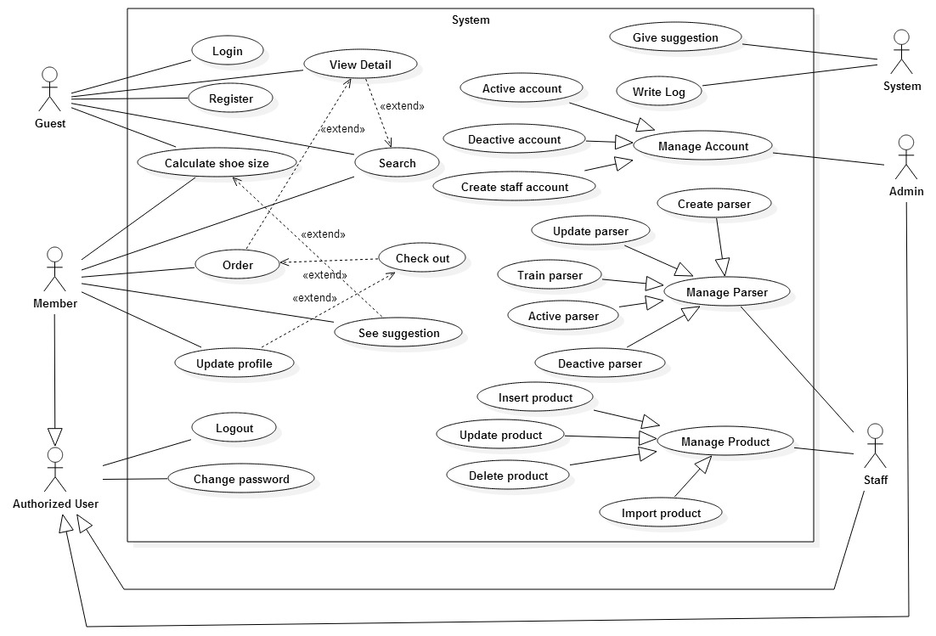

Figure 1: System Overview Use Case

### List of Use Case

#### < Administrator >Overview Use Case

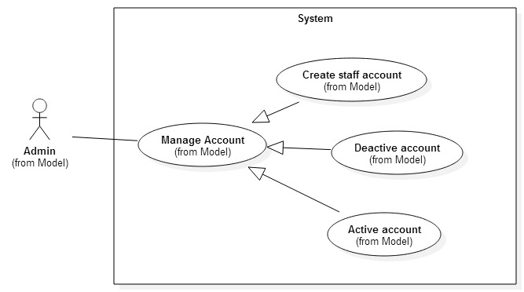

Figure 2: < Administrator > Overview Use Case

##### <Administrator > Manage user account – Create staff account

Use Case Diagram

Figure 3: < Administrator > Manage user account – Create staff account use case diagram

##### <Administrator> Manage user account – Deactivate user

## Software System Attribute

### Usability

#### Graphic User Interface

* All the texts, labels and should be written in Vietnamese.

#### Usability

* Administrator, staff should need less than one week of training to be productive with the system.
* Guest and member can use the system easily without training.

#### Installation

* The system must be easy to deploy.
* Customer can deploy successfully and learn to configure, maintain the system within one day of training.
* The attached manual guide must be clear. User can read and do themselves without developer’s help.

### Reliability

- The price should be updated every day.

- The parser should be updated every day.

- If the product is already existed, system will notify for user.

### Availability

* N/A

### Security

* Privacy: Each role of user has a specific permission to interact with system.
* System always checks authorization and authentication before doing anything.
* Only administrator can grant permission to staff.

### Maintainability

* The system is divided into separated modules.
* The code is easy to maintain and upgrade.

### Portability

* N/A

### Performance

* N/A

## Conceptual Diagram

### Data Dictionary

|  |  |
| --- | --- |
| Entity Name | Description |
|  |  |
|  |  |
|  |  |
|  |  |
|  |  |
|  |  |
|  |  |
|  |  |
|  |  |
|  |  |

Entity Data dictionary - Describe content of all entities